FREEHEARTS AFRICA REACH OUT FOUNDATION ANNUAL REPORT FOR FISCAL YEAR 2017

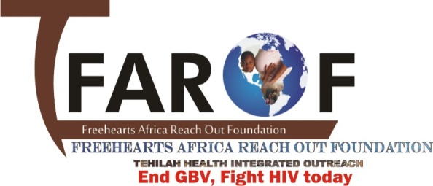

PROJECT TITLE:
PROVIDING COMPREHENSIVE HIV/AIDS SERVICES FOR AYPs

TABLE OF CONTENTS

Title page
Table of contents
- Project Overview…………………………………………………………………………………………………………………..3
- Introduction………………………………………………………………………………………………………………………….4
- Description of Activities…………………………………………………………………………………………………………5
  - Advocacy……………………………………………………………………………………………………………………………5
  - Assessment of AYPs……………………………………………………………………………………………………………5
  - AYP sensitization and volunteer selection process……………………………………………………………..5
  - Trainings/capacity building…………………………………………………………………………………………………6
- Condom programming…………………………………………………………………………………………………………..7
- Notable Achievements…………………………………………………………………………………………………………..7
- Challenges……………………………………………………………………………………………………………………………..7
- Picture gallery………………………………………………………………………………………………………………………..8

- PROJECT OVERVIEW
The Adolescent & Young People Project (AYP) is a UNICEF supported program that aims at scaling up HIV combination prevention, treatment and care services for adolescents and young people in Birnin gwari Local Governments Area (LGA) of Kaduna State.
In 2012, the World Health Organization estimates that there were about 2.1 million adolescents living with HIV in the world. This group between the ages of (10-24) years, are particularly vulnerable to HIV due to physical, emotional and social developments and are estimated to account for about “one seventh” of all new HIV infections globally. In Nigeria, The National Bureau of Statistics (2015) estimates the country’s population at 183 million, over 30% of which are estimated to be between the ages of (10-24) years, of which over 2.4 million are living in Kaduna State.
The NARHS (2012) estimates Kaduna states’ HIV prevalence at 9.2% with an estimated 600,000 people living with HIV; the rural areas had a prevalence of 9.1% and the urban areas 9.7%. The prevalence among young people aged (15-19) years was 11.7%.
According to the Kaduna State HIV & AIDS, Sexual and Reproductive Health survey (SHARHS 2014); amongst adolescents (15-24) years, 85% of both sexes have heard of HIV, yet only an average of 4.7% were able to correctly identify all five ways of HIV transmission. In addition, only 14.3% & 57% identified delay in sexual debut and consistent condom use respectively as a way to prevent HIV infection. With 72% of males and 98% of females aged (15-24) years ever having had sex, there is evidently a need for an intensive and targeted intervention amongst adolescents and young people in the state.
In order to address this rising concern, FAROF with support from UNICEF, carried out various activities in Birnin-gwari which was geared at adopting holistic and drastic measures to raise awareness in our community on HIV and AIDS, and creating an enabling environment to raise demand for HIV Testing services including uptake of referrals
The following strategies were adopted in order to successfully carry out this project
Advocacy
Community awareness
Capacity building

- Introduction
FAROF was Founded as a charitable non-profit organization, to fight stigma and discrimination, end gender base violence against young women/girls, with her thematic areas centered on Preventive intervention programs and sexual reproductive health and rights SRHR activities of Adolescents and young people living with HIV, FAROF coordinates HIV response on adolescents, young people and youth living with HIV/AIDS in Nigeria. Adolescents and Young People experience numerous degrees of developmental challenges at varying pace, which includes: evolving sexuality, increasing need for independence, peers and broader social connections. The adolescent period is also marked by increased involvement in risk behaviors that may predispose young people to poor long-term outcomes. Many of these risky behaviors are relatively transitory in nature and are resolved by the beginning of adulthood. The increase in ignorance by our community leaders of Adolescents and young people, is leading to increase in new HIV infected young person’s and has put the organization to stand against such ignorance and getting more young people aware of their rights, as well as creating wider awareness of the SRHR programs to reduce risky behaviors amongst young people within our community. FAROF identifies factors (individual, social, environmental and systemic) that increase vulnerability of young people, transgender youth and young people with disability to HIV & AIDS and develop a preventive strategy for programming for Adolescent and Young people who inject drugs, Adolescent and young female who sell sex, Adolescent and young men who have sex with men using the Combination Prevention Approach (Behavioural intervention, Biomedical intervention and Structural intervention)

- DESCRIPTION OF ACTIVITIES
  - Advocacy
The project commenced with an advocacy and sensitization meeting carried out in the community to create wider awareness on AYP activities for Birnin Gwari LGA to community members and to sensitize the community leaders.
Possible means of partnership was discussed during the meeting which was centered on provision of security during the implantation of the project and monitoring the implementation of the project to ensure success on service delivery. The communique was read and signed by the chairman.
Present for the meeting was the chairman, Director of Primary Health Care, religious leaders, 11 ward heads and AYPs. The sensitization meeting was held for two days.
  - Assessments of AYPS
FAROF engaged in the Adolescents and young people (AYP) Assessment program conducted in two LGAs of Kaduna State, namely Kargarko and Birnin gwari LGA, supported by UNICEF and State AIDS control Agency SACA as the host. These Assessment was conducted on the following dates, in Kaduna state from 13th June, 2016 to 17th June, 2016 and Benue state from 17th June, 2016 to 21st June 2016 respectively. Representatives of UNICEF from the office of New York was present, the following stake holders where present during this Assessments, these include: Local Government AIDS Control Agencies (LACA) M&E officers, CSOs, representatives from the office of UNICEF. Assessment carried out was focused on the following interventions:
- HIV testing and counselling for adolescents
- Antiretroviral therapy (ART) for adolescents living with HIV
- Condom use among adolescents
- In-school life skills-based HIV prevention and reproductive and sexual health education

  - AYP sensitization and volunteer selection process
A total of 110 AYPs were invited from the 11 wards in Birnin Gwari LGA ( Damari, Kuyallo, kutemeshi, Gayam, Kakangi, Randagi, Dogon dawa, Magajin Gari 1, Magajin Gari 2, Magajin Gari 3, ) to be engaged in meaningful dialogue/sensitization and selected as volunteer for AYP Program implementation in Birnin Gwari LGA.
Their role was to serve as demand creators and counsellor testers in various political wards of the LGA and also identify various HCT/HIV service center
The selection process done by conducting a written test and oral interview. At the end of the whole exercise, 66 AYPs were selected to be trained as demand creators and 22 as counselor testers.
  - Training/capacity buildings
In the project period, the selected AYPs were trained for 5 days to build their capacities as demand creators. The objectives of the training was to;
- Empower AYPs with leadership skills that will aid them reach out to their peers.
The capacity building training addressed the following important points
- HIV prevention, control and misconceptions, how HIV is transmitted, difference between HIV and AIDS and HIV prevention medical services.

- The trends of HIV in Nigeria, the HIV epidemic among AYPs as well as mode of transmission and the socio-economic factors facilitating the transmission, Barriers to taking preventive precautions such as cultural practices and traditional beliefs.

- counselling and testing, goals of counselling and testing, its benefits, modes of counselling and testing service delivery, target populations, problems surrounding counselling and testing, the core principles, and maintaining a human rights approach.

- Communication skills, components of effective communication, barriers of effective communication and ways to overcome such barriers, understand the importance of feedback and skills for effective communication.

- General principles in code of conduct for HIV counselors, matters on consent and confidentiality, when counselors may break confidentiality agreement, and other ethical considerations.

- Decision making, assertiveness and negotiation skills

- Male and Female condom demonstration, negotiating condom use, abstinence and unplanned pregnancy, sexually transmitted infections

- use of condom, pre-test counselling and post-test counselling, referrals and positive living, counsellor burnout and stress management, how to fill the HCT client intake form, HCT monthly summary form, daily HIV test worksheet and client referral form.

- Condom programming
Under this program, the AYPs constituents of FAROF which is known as Network of Adolescent Gender (NAG) carried out various activities targeted at the young ones such as family planning through condom promotion, sensitization/awareness workshops on SRHR to promote family planning techniques for adolescent girls and young women, reduce new HIV infections, stop stigma and discrimination amongst AGYW and fight gender based violence.
A youth friendly center was established at Kaduna North LGA for the AYPs to freely access condoms on weekly bases and educational talks on sexual and reproductive health rights were provided through this platform, HIV and malaria tests were conducted and results were provided to all that were tested.

- Notable Achievements
- Reached 14,000 AYPs with HTS in Birnin gwari , Kagarko and Kaduna North LGAs in Kaduna State.
- 12000 AYPS were reached with HTS in Birnin gwari and Kagarko LGAs, of Kaduna state.
- 308 AYPs were trained as Demand creators in Kaduna State, Nigeria
- Trained 28 AYPs as HIV testers and Counselors in Kaduna State, Nigeria.
- Sensitized 23,000 AYPs in the community with HTS messages.
- Organized Street campaign with AYPs living with HIV in Kaduna State.

- Challenges

- Inadequate supply of logistics (for the transportation of commodities to site and stipends) for PCVs distributing the condoms.
- Insufficient funds and high maintenance cost during project implementation
- Insufficiency of IEC materials in terms of language and messages
- Poor internet service in communities.
- Poor mobility into hard to reach areas for monitoring and project supervision

Picture gallery
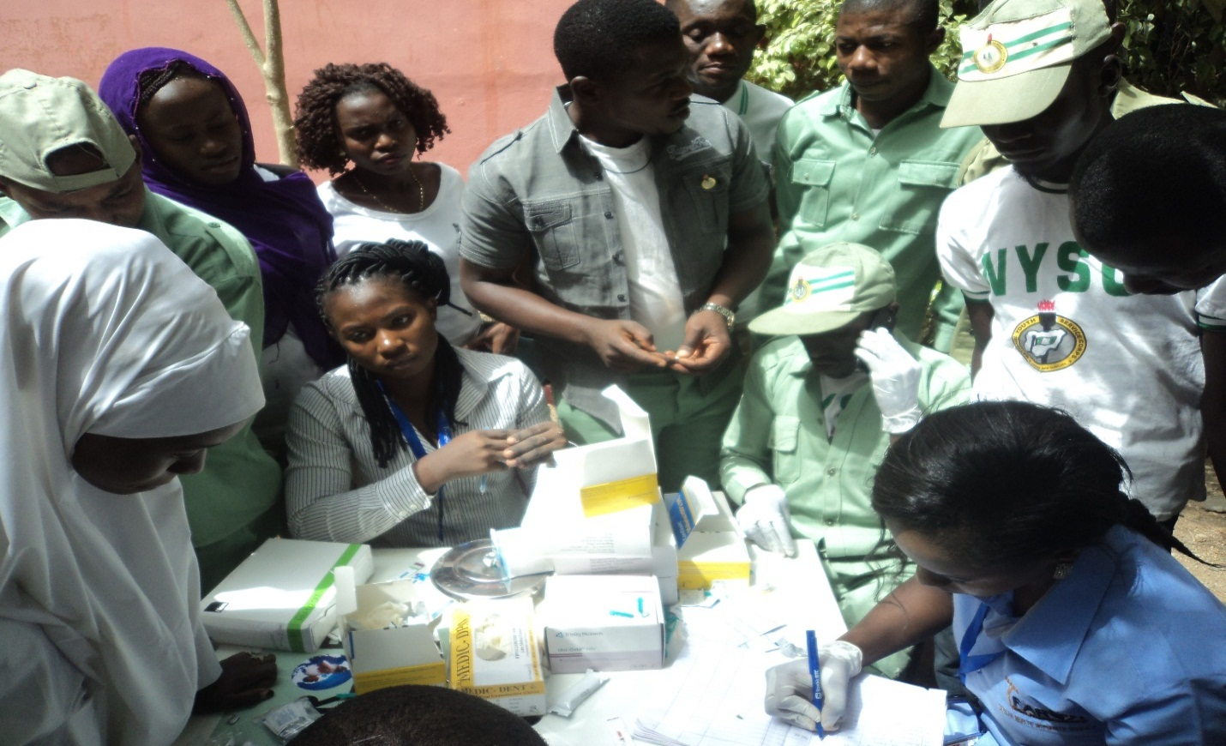
Conducting HIV tests for AYPs
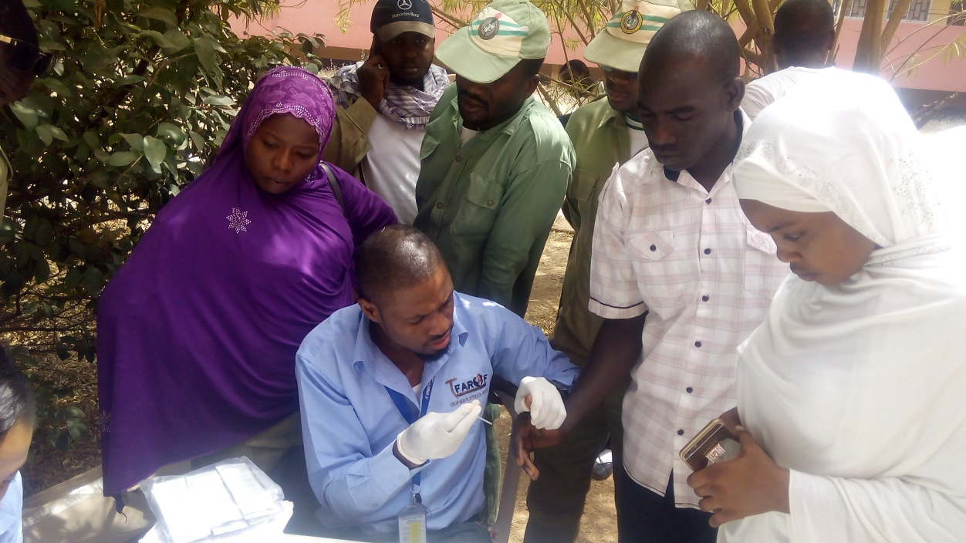
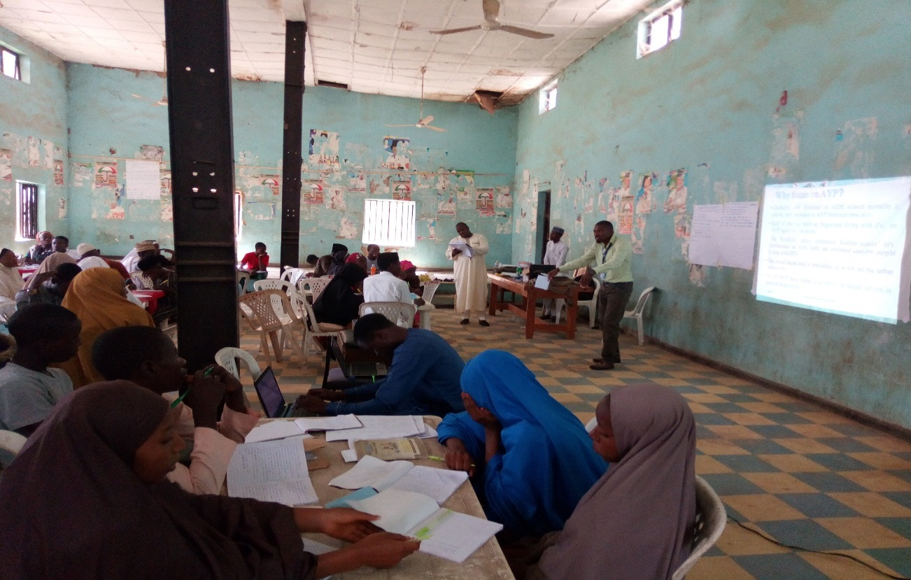
Training AYPs as demand creators
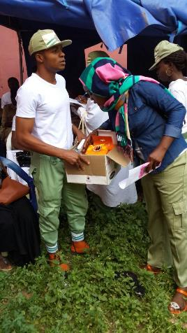
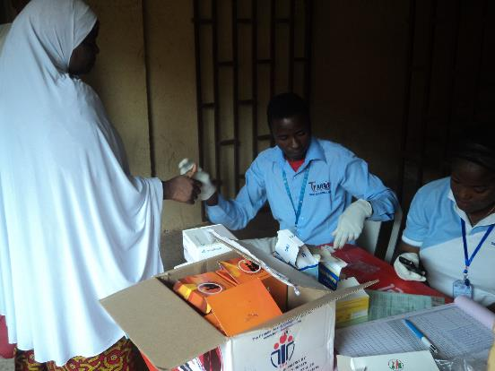
AYPs distributing condoms and conducting HIV and Malaria Test at the Youth Friendly center

