FREEHEARTS AFRICA REACH OUT FOUNDATION ANNUAL REPORT ON GBV FOR FISCAL 2017

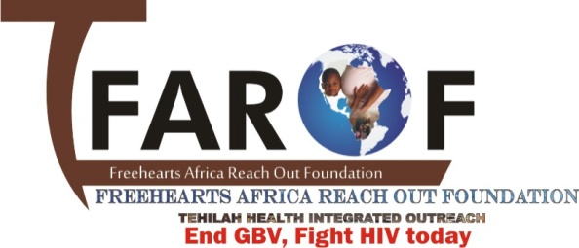

PROJECT TITLE:

Enhancing Adolescents Girls and young women’s AGYW’s Capacity to Prevent and Respond to Gender Bases Violence through community participation)

TABLE OF CONTENTS
Title page
Table of contents
- Summary……………………………………………………………………………………………………………………………….3
- Introduction…………………………………………………………………………………………………………………………..4
- Overall description of activities……………………………………………………………………………………………5
- Assessment of progress made……………………………………………………………………………………………..5
- Condom programming…………………………………………………………………………………………………………..9
- Challenges……………………………………………………………………………………………………………………………10
- Lessons learnt………………………………………………………………………………………………………………………10
- Picture gallery……………………………………………………………………………………………………………………11

- SUMMARY
FAROF positions itself to be a youth organization striving for social justice and to ensure that young women are given opportunities to fully enjoy their rights. One of the approaches that the organization has adopted is to raise youth awareness on gender equality and violence free families, by working with local leaders, community members and networking with other actors working on gender equality and GBV issues.
Gender-based violence is an all-pervasive issue affecting the lives of one in three women in most communities. FAROF’s program on prevention of violence against adolescent girls and young women uses a convergent multi-stranded, technology-backed approach to prevent and respond to gender-based violence.
The program supports public systems, namely the police and health systems, to respond better to women facing violence, empowers communities to address and prevent the incidence of gender-based violence, and provides services that enhance mental health and secure legal rights of those affected GBV. In keeping with the 2030 Agenda for Sustainable Development, the program works towards Sustainable Development Goal 5 - ‘achieve gender equality and empower all women and girls’. FAROF’s experience of addressing gender-based violence has shown that bringing violence into the public arena, talking about it openly, and motivating people to respond creates an enabling social environment in which people gradually become less tolerant of gender-based violence. This leads in turn to more women reporting violence and seeking help to change their situation. FAROF has realised that it is important to carry out prevention activities that promote healthy behaviours, knowledge of rights and entitlements, and women’s capacity to counteract violence, foster safe environments that reduce the risk of violence, and create support networks
With that regard, FAROF has implemented series of activities at Birnin gwari and Kaduna North LGAs, aiming at promoting gender equality and preventing domestic violence from its root causes and that, through engaging youth and providing them with readiness for marital life.

- INTRODUCTION
Gender-based violence (GBV) is one of the most widespread human rights abuses in the world. Globally, one in three women will be raped, beaten, coerced into sex or otherwise abused in her lifetime. Though women and girls are overwhelmingly the targets of GBV, men and boys can also be subject to GBV, especially if they are perceived to be acting outside the prescribed social norms for males. This abuse takes place worldwide in homes, workplaces, schools and communities.
Ending GBV involves social change work at the deepest levels and the commitment of individual at the grass root level.
This report reviews FAROF’s work to tackle GBV based on program evaluations carried out for the fiscal year 2016. Some of FAROF’s most successful programs were in Birnin gwari LGA, where staff worked to address violence at home, to engage men and boys as champions of change and to mobilize community action against GBV. FAROF supported services for survivors of GBV and worked with coalitions and networks to advocate for policy change in line with national agreements for addressing GBV. In fiscal year 2016, our programs tackling this abuse reached more than 50 people.
Why this report? Measuring the outcomes of programs tackling GBV poses well-known challenges. Starting with this publication, FAROF wants to contribute to finding solutions and ways forward for obtaining more accurate data about the approaches that have greatest success in tackling GBV. This review has helped identify successes and challenges. This learning is an essential step for working more effectively to end GBV through FAROF’s future actions.
The report is also intended to increase FAROF’s accountability to governments and civil societies based on its program evidence. We believe strongly in the importance of transparency regarding our achievements, as well as our limitations. We feel that this openness will enhance our relevance and legitimacy, and ultimately improve the future quality and impact of our work, which is so vital given the scale of GBV.

- OVERALL DESCRIPTION OF ACTIVITIES
FAROF GBV project in the year under review dealt mainly on community sensitization, conducting GBV assessment, and running advocacy works that facilitate to mitigate the overall GBV problem and create the ground for provision of direct services for OVC..
The project focused on the following areas of intervention:
- Baseline assessment of GBV survivors
- Assessing survivors’ needs
- Referring survivors for medical services, psychosocial care, and social and economic reintegration services
- Provision of training and technical assistance to community-level committees to lead GBV prevention efforts
- The training of health care providers in the care of SV survivors
- Condom programming
- Capacity building AGYW SRHR

The project’s supply-side efforts included facilitating access to services for 30 survivors and training health care providers. Work in the community to address GBV contributed to the enabling environment and demand for services. Training for GBV prevention committees and health care providers were selected as the first steps in longer processes of transforming gender norms and improving SV service quality.

- Assessment of progress made
  - Identification of survivors of GBV through Baseline survey
Baseline survey was conducted by FAROF team supported by the project community volunteer in three communities of Birnin gwari LGA, which are birnin gwari town, Randegi, and dawaki bassa. This study provides a baseline situation on GBV in birnin-gwari LGA of Kaduna State.
The objectives of the survey were to establish the nature and extent of human rights violations particularly Gender Based Violence, the challenges to the observance of the rights of women and children in the community, map out the existing mechanisms for redress, assess key issues pertinent to improving access to justice for victims of Gender Based Violence.
A total of 120 people participated in the survey. Data was collected from police official, health worker and the district head.
A well-structured questionnaire was administered to the target population (women) in the community through systematic random sampling to gather data randomly.

This survey indicated a number of human right issues particularly relating to GBV prevalent in Birnin-gwari as follows;
- Rape
- Child abuse
- Child marriage
- Hitting and slapping
- Denial of contraception
Ethical clearance was gotten from the Ministry of Health (MOH) before the survey was conducted.

  - Using community structures to Influence and change the social norms that condone violence.
Through multiple strategies, such as engaging couples to address violence and mobilizing community action, FAROF seeks to change behavior by challenging the social norms that perpetuate violence. Our efforts include working with men and boys as champions of change –enabling them to challenge gender norms and enjoy more equitable relationships in their own lives. We also address gender inequality by supporting activities, such as economic development, education, leadership and life skills training, that increase women’s and girls’ ability to know and claim their rights and help reduce their vulnerability to violence.

  - Engaging couples to address violence
FAROF worked with men and women to prevent violence in ‘intimate partner’ relationships - the most common form of GBV in the community.
FAROF conducted couples’ dialogue sessions to address the issue of unequal power relationships between men and women. A marked improvement in communication between spouses has resulted in women and men having a better understanding of the root causes of GBV, and men playing a more active role in domestic duties.
Model couples’ were adopted, i.e. those who live in equal relationships – as an example to other couples and the wider community.
Forums were created for men and women to discuss issues that contribute to GBV such as alcoholism, gambling, domestic violence and polygamy. The approach uses personal stories of change to help men in the community work towards non-violent and more equal relationship with women and girls. As part of the program, a couple who has signed up to it may ‘adopt’ two other couples to support their journey towards a violence-free relationship. These two ‘model couples’ will in turn work with other couples to create a multiplier effect across the community.

  - Men and boys as champions of change
To tackle GBV, FAROF worked in close partnership with men and boys. Our experience indicates that engaging men and boys to challenge views that see violence as part of manhood is key to achieving greater equality between women and men. This work seeks to enable men and boys to become agents and activists for change and to challenge and explore alternative masculinities based on justice and human rights.
FAROF works with men and boys across a range of programs, from challenging their attitudes to women to working with male community leaders to end traditional harmful practices such as child marriage and invest in the wellbeing of girls and women in their communities.
FAROF’s program used a mix of capacity building and educational strategies to transform men’s behavior. The male participants came from rural areas and had been physically and verbally violent towards their wives. Their reasons ranged from anger and frustration and the need to feel more powerful to a lack of understanding of the impact that violence was having upon their wives and children.
The program showed a gradual change of men’s behavior toward their wives, most being able to control their aggression. This experience evidenced that by engaging men and boys as partners and allies against violence, they are able to better understand the causes and costs of GBV and the benefits of non-violent behavior, most being able to make positive changes in their own lives.

  - Supporting survivors through quality care.
FAROF recognizes that GBV affects all aspects of survivors’ lives –including their legal and economic status, and their health and emotional wellbeing.
FAROF worked extensively with traditional leaders and other community members to create awareness and behavior change regarding GBV, with 15 traditional and other local leaders sensitized on GBV, 52 percent of whom were women leaders. FAROF worked with community leaders, taking care not to single out survivors and stigmatize them, to establish and build the capacity of local community support systems that help keep survivors safe from domestic violence, such as community watch groups and safe houses. Sometimes, the most critical need for the communities with which we work is to identify and raise awareness of services for GBV survivors already available to them.

  - Providing Psychosocial services

Psychosocial care was provided for 30 survivors of GBV identified from the baseline survey. This psychosocial care took the form of counseling from trained psychiatrist who has experience dealing with survivors of GBV. The victim were counselled on mental health and crisis managements, and 65% of the women showed an improved sense of self-esteem, while 72% survivors showed an improved sense of well-being through lower stress level.

Several survivors expressed deep gratitude for the psychosocial care they received. A mother who received therapy from the psychiatrist said: “I wish to thank the project and tell the providers of the project that they changed our lives after that violence, because I even wanted to commit suicide after what happened to me, but it's they who gave me the courage to continue to live.”
Regular follow up was done by the community volunteers through home visits.

  - Provision of household economic strengthening
It was discovered poverty was a leading cause of gender based violence experienced among women, as most of this women do not have a source of income and so this women could not contribute to any decision making process In their homes. FAROF saw the need to empower these survivors with various skills to be able to provide for themselves and families.
30 survivors of GBV were enrolled to acquire various vocational skills such as cosmetology, bag making, tye and dye, tailoring, bead making. At the end of the training, start-up materials were provided for them to start earning so as to ensure that they were able to make contributions to the affairs of their families.

  - Training and workshops
In the project period community level awareness raising workshops have been carried out on GBV, gender norms and HIV/AIDS.
The sensitization workshops have been given to pertinent bodies in respective community representatives, police, judiciary, community and religious leaders. Special emphasis was given to address men and boys involvement in addressing GBV issues in the community.
The major objectives of the workshops were to:
- Obtain men’s /women perception on equality between women and men and see how men’s understanding impact on the realization of gender equality and in perpetuating discriminations women suffer under rules of patriarchy;
- Sensitize men, women, girls and boys and other community members on the negative impacts of GBV and thereby identify with the participants the roles they could play to combat GBV and other discriminatory practices;
The sensitization workshop sessions addressed the following important points:
- Current situation (status and position) of women and girls in the respective localities; equality between men and women
- The prevalence of gender-based violence and major causes of GBV and their consequences;

- Community perceptions, narratives and myths as well as structures and institutions perpetuating GBV and other harmful traditional practices;
- Major obstacles that women perceive prevent victims from seeking and accessing institutional remedies; and
- The roles as well as responsibilities of various community structures and institutions in the combat against GBV.

  - Training of health care providers
FAROF conducted a three days training on gender based violence for eight (8) Health care providers at Jibril Maigwari memorial hospital, Birnin-gwari, to strengthened their knowledge, attitudes, and skills related to the provision of quality services to sexual and domestic violence survivors.

- Condom programming
Under this program, the AYPs constituents of FAROF which is known as Network of Adolescent Gender (NAG) carried out various activities targeted at the young ones such as family planning through condom promotion, sensitization/awareness workshops on SRHR to promote family planning techniques for adolescent girls and young women, reduce new HIV infections, stop stigma and discrimination amongst AGYW and fight gender based violence.
A youth friendly center was established at Kaduna North LGA for the AYPs to freely access condoms on weekly bases and educational talks on sexual and reproductive health rights were provided through this platform, HIV and malaria tests were conducted and results were provided to all those that were tested.
About 300 AYPs were educated on their Sexual and Reproductive Health Rights, how to avoid unplanned pregnancy and how they can negotiate with their sexual partners on the use of condoms to avoid STIs and unwanted pregnancies.

- Challenges
- Weak coordination and networking among the stakeholders for protection of GBV
- Limited resource and project scope as compared to the extensive nature of the problem
- Resistance from wrong attitude of the community, even the literate people on gender, GBV and girls/women’s rights
- Majority of women in the rural areas are illiterate and economically dependent for the proper implementation of formulated laws.
- Limited community awareness, the resistance due to wrong/biased attitudes of the community, the literate people on gender, GBV & Girls/Women’s rights.
- Time constraint to implement all planned activities. As there are several follow-up works which mainly focus on strengthening of all the stakeholders, was good if the project life was longer or if there is another project that can take over the responsibility to see to sustained efforts against the GBV.
- Shortage of well-trained resource persons for advocacy and community awareness raising workshops

- Lessons Learnt
- Community participation in the facilitation and coordination of trainings and education sessions is very encouraging, it is also cost effective.
- Women’s discussion towards changing the social stigma and in taking initiatives to coordinate trainings and solve the problems of GBV is highly encouraging.
- In order to make the intervention more effective and efficient, the need of establishing networking and referral linkages with all duty bearers and service providers is an imperative aspect.

- Picture gallery

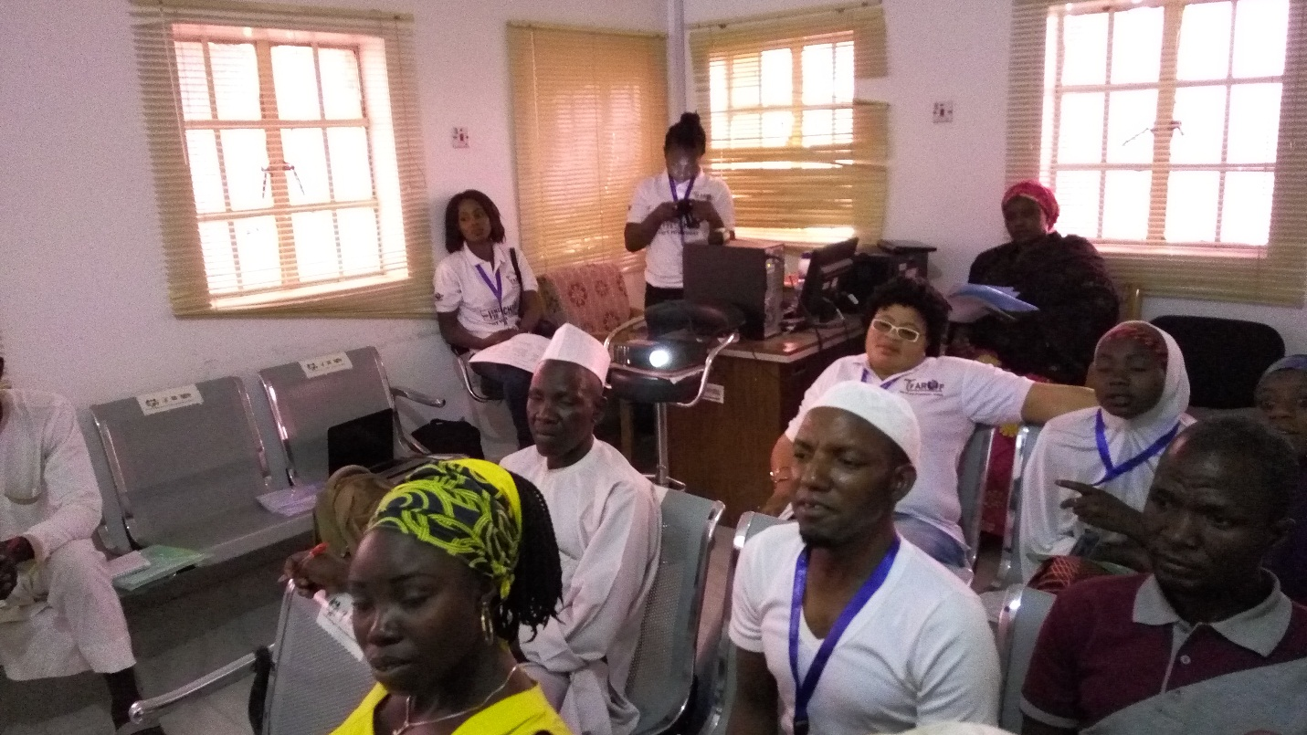
Health care providers training session on GBV
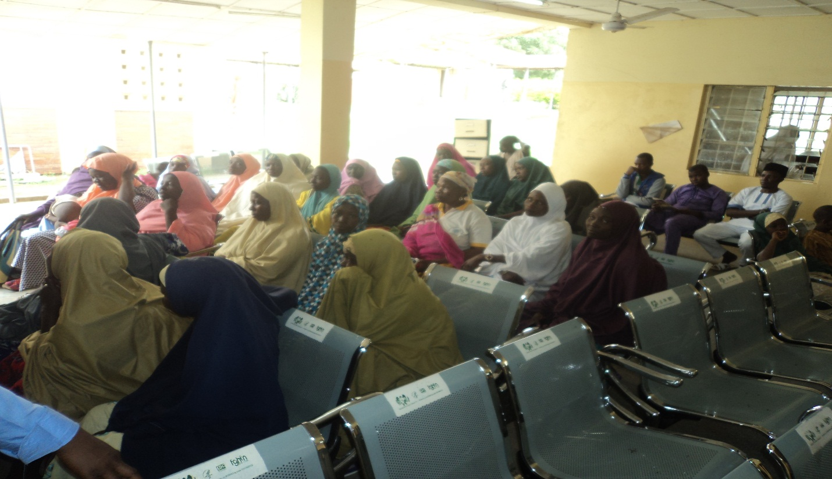
Educating the community members on gender norms
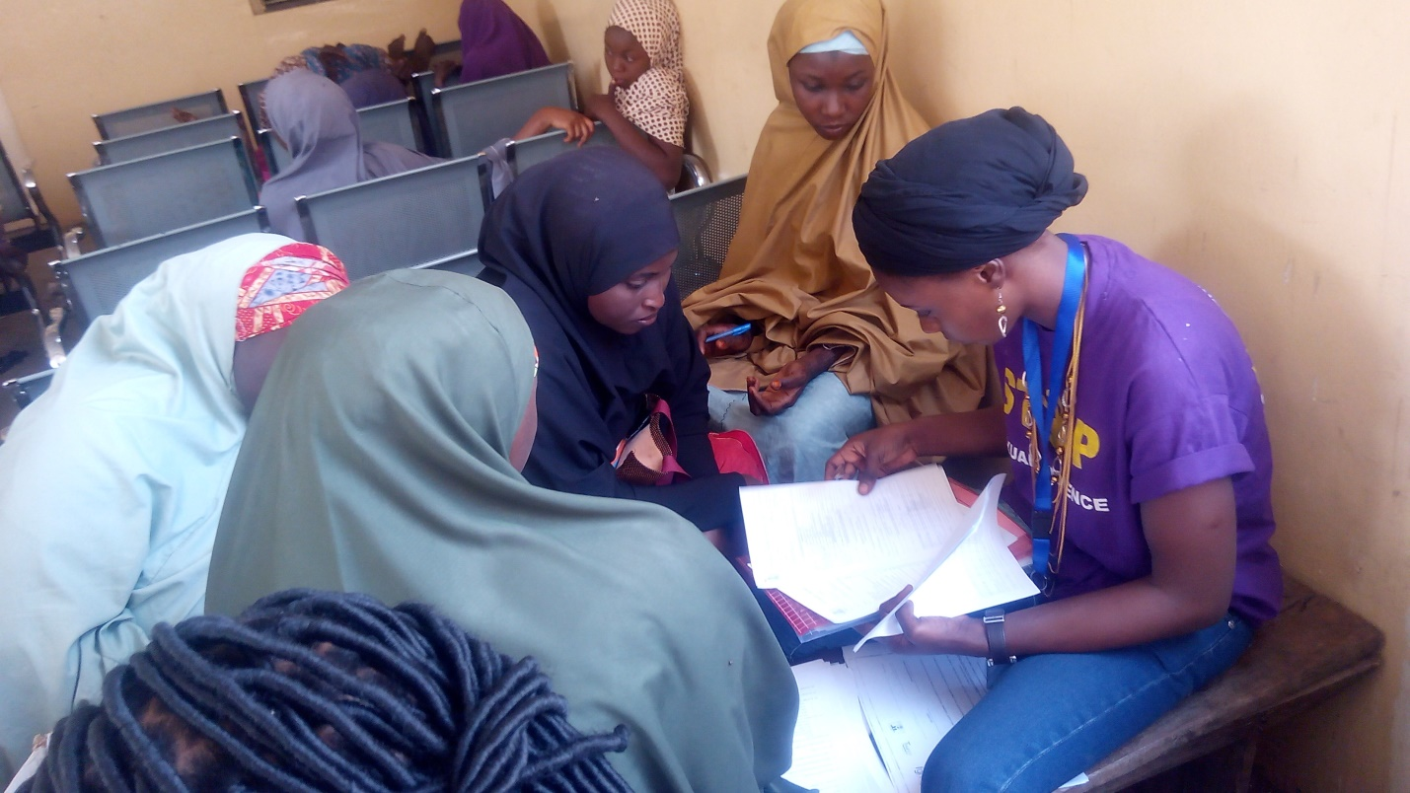
Sensitize adolescent girls on Sexual Reproductive Health and Rights-SRHR

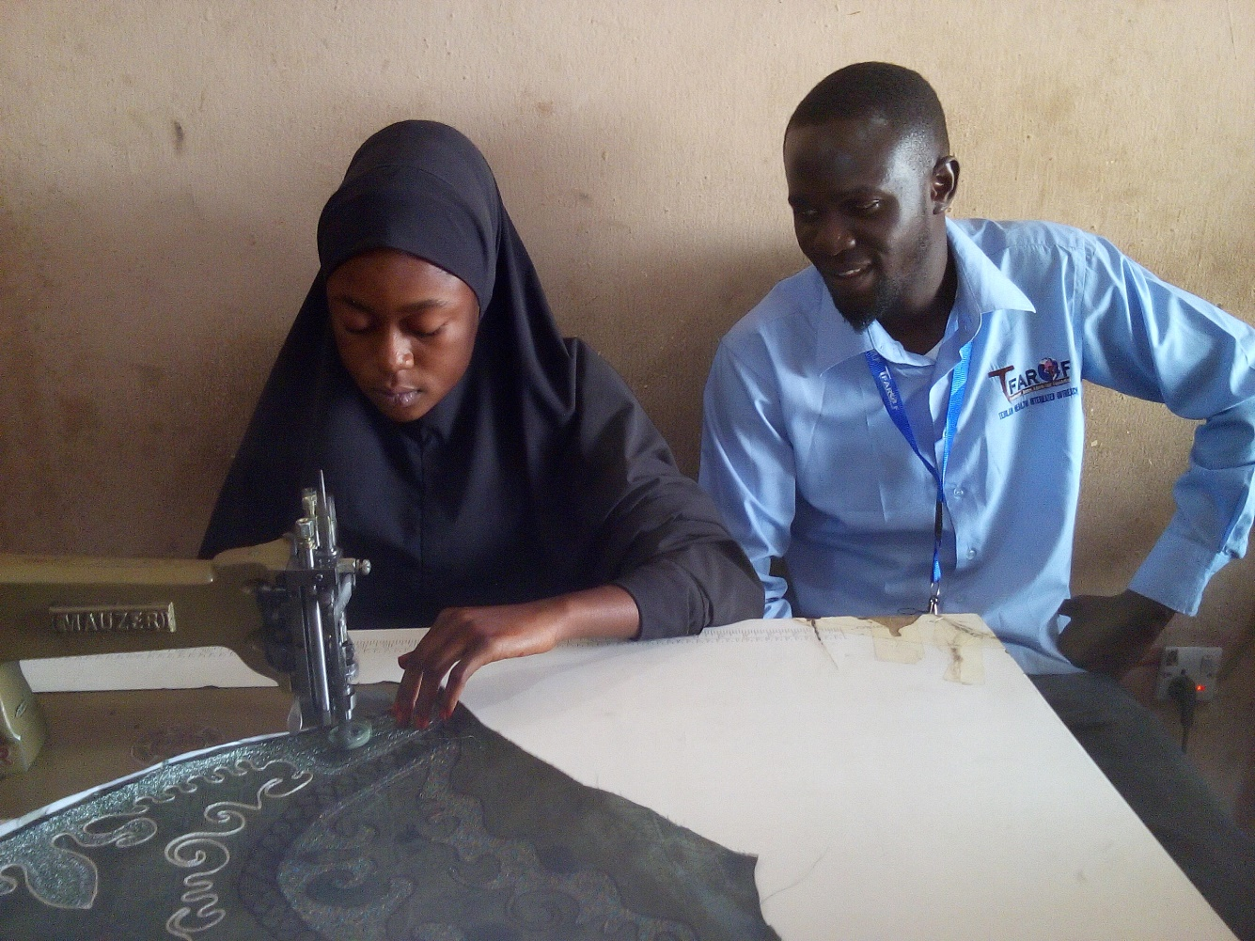
Survivor of GBV enrolled into life skills

