FREEHEARTS AFRICA REACH OUT FOUNDATION
2017
ANNUAL REPORT FOR
Comprehensive service for OVCs and households
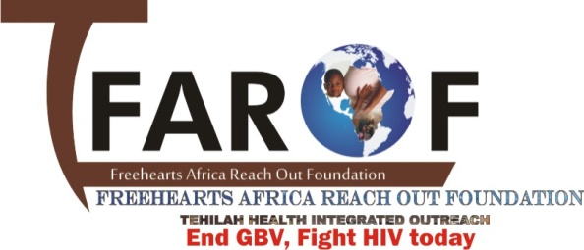

Project Title:
Engaging Indigenous Organizations to Sustain Comprehensive HIV/AIDS Services in Nigeria

TABLE OF CONTENTS
Title page
Table of contents
Acronyms
- Executive Summary………………………………………………………………………………………………………………4
- Introduction………………………………………………………………………………………………………………………….5
- Beneficiaries………………………………………………………………………………………………………………………….6
- Services Provided…………………………………………………………………………………………………………………..6
- Monitoring and Evaluation……………………………………………………………………………………………..…..10
- Key achievements………………………………………………………………………………………………………………..11
- Challenges……………………………………………………………………………………………………………………………12
- Recommendation………………………………………………………………………………………………………………..12
- Lessons learnt……………………………………………………………………………………………………………………..12
- Picture gallery…………………………………………………………………………………………………………………….13

ACROYMNS
LGA – Local Government Area
FGHIN – Friends for Global Health Initiative in Nigeria
FAROF – Freehearts Africa Reach Out Foundation
OVC – Orphans an Vulnerable Children
HIV- Human Immunodeficiency Virus
AIDS – Acquired Immune Deficiency Syndrome
PCV – Project Community Volunteers
GBV – Gender Based Violence
VC – Vulnerable Children
MUAC- Mid Upper Arm Circumference
IEC- Information, Education and Communication
VSLA – Village Savings and Loans Association

- EXECUTIVE SUMMARY
The project on Engaging Indigenous Organizations to Sustain Comprehensive HIV/AIDS Services in Nigeria was successfully executed by the Freehearts Africa Reach Out Foundation in nine communities of Birnin-gwari LGA. Implementation period for this project spanned from September 2015 to September 2017. The project was executed with funding from FGHIN. The overall goal of this project is to promote access of HIV exposed and infected children as well as orphans and vulnerable children (OVC) to essential care and support services for improved standard of living and development.
During the year under review, essential care and support services were provided for 1200 OVCs in terms of home based care as well as educational, health, nutritional, psychosocial support in nine (9) target communities of Birnin-gwari LGA of Kaduna state. Specific project interventions that was carried out during this period in achieving this goal were advocacy to community leaders, community dialogue and capacity training for PCVs. Other strategies include provision of health, nutritional, psychosocial, educational supports as well as monthly review meetings with PCVs, home visits for care and support by PCVs, monitoring and evaluation of project activities and report production, and distribution.
A major success story is that action plans were developed by the community leaders to guarantee the sustainability of the project.
Identified critical challenges/constraints associated with the project during the year under review was poverty and food insecurity among the OVC households which promoted persistent health problems with the OVCs. In addition, most of the OVCs households were located in hard to reach areas that were inaccessible as well, because of bad terrain.
Major recommendation include conducting a needs assessment of the OVCs priority intervention would have provided the need information for prioritizing what should be provided to them. Secondly, future OVC interventions should integrate both the in-school and out-of-school (un-enrolled) OVCs to promote equity and fairness. Finally, there is the need to scale-up OVC interventions to give opportunity to other children in both benefitting and non-benefitting communities in Birnin-gwari LGA of Kaduna State
.

- INTRODUCTION
Freehearts Africa Reach Out Foundation (FAROF) is a non-governmental organization founded on the 15th December 2011 and registered with the corporate affairs commission under the part C of the allied matters Act 1990.
Since inception, FAROF has been engaged with various activities which are focused on HIV/AIDS prevention, care and support, orphans and vulnerable children, family planning programs, adolescent and Young Persons living with HIV, gender based violence programs (GBV) and the host of others.
The organization successfully executed a project titled “Engaging Indigenous Organizations to Sustain Comprehensive HIV/AIDS Services in Nigeria”, which was funded by FGHIN. This project was implemented in nine communities of birnin-gwari LGA. The overall goal of this project is to promote access of HIV exposed and infected children as well as orphans and vulnerable children (OVC) to essential care and support services for improved standard of living and development.
In achieving these goals, a number of services were provided to OVC and their families. These comprise psychosocial support, educational support, HIV prevention education, basic health-care services (including home-based care and referrals), food and nutritional support, and child protection. These services are made available via activities – the vehicle for providing services.
During the year under review, the Key activities the project engages in are networking, home visits and community sensitization.
To supply a comprehensive auxiliary service of home-based and OVC care, FAROF worked with volunteer caregivers.
Staff members also work closely with teachers and schools to guide HIV/AIDS support groups, and ensure OVC have access to education. FAROF also assist OVC in the application of documentation such as birth certificates. The project conducts public education programmes (focusing predominantly on HIV prevention education).

- BENEFICIARIES
There are 1,200 OVC beneficiaries in Birnin Gwari LGA (695 females and 505 male) from a total of 510 households. Most OVC beneficiaries are under age 18. Beneficiary identification was completed at project outset; new beneficiaries were not added during the reporting period. OVC beneficiaries were identified by the PCVs; however, more OVC were identified than the project had the capacity to serve. The PCVs then prioritized children who were “most vulnerable,” including OVC living in child-headed homes, with an elderly caregiver, or with an ill guardian. The PCVs established a criteria to prioritize OVC, utilizing information from initial assessment forms and the knowledge acquired during home visits.
In addition to identified OVC counted as “beneficiaries,” many other children in the community benefit from the stronger education infrastructure built by the project. For example, renovation of school classrooms and sanitary systems and encouragement of group counseling and Kids clubs in primary schools supports many VCs in the community.
- SERVICES PROVIDED
Services were offered to OVC as a package; thus, every beneficiary received at least four essential services. These comprise food and nutritional support, child protection support, general health care services, educational support; HIV prevention education; psychosocial support, and Household Economic Strengthening. Though all beneficiaries typically receive the same package of basic services, services such as vocational training were targeted based on eligibility, need and available resources.
  - Education support
The Sustainable Development Goal for education calls for the international community to “ensure inclusive and equitable quality education and promote lifelong learning opportunities for all” by 2030. Within this broad agenda, FAROF continues to focus on the educational needs of the most marginalized. Recognizing that exclusion is driven by poverty majorly.
FAROF through its program for the year 2016 provided learning materials such as text books for four primary schools namely, Anguwan Shittu, Jibril Maigwari, Tundun Jega and UBE Unguwan Dan Zuru in Birnin Gwari LGA. School uniforms, and stationerires were also provided for 500 OVCs
The program also renovated the classrooms of Jibril Maigwari Primary school and Anguwan Shittu primary school, to provide a conducive learning atmosphere for the OVCs in these schools. In a bid to promote and encourage the retention of the girl child in school, FAROF renovated the dilapidated sanitary systems of 5 schools
Educational assessments was conducted periodically to monitor the progress and performances of the OVCs in school.

  - Food and Nutrition Support
Under the food and nutrition support, FAROF carried out regular food educational sessions to caregivers and OVCs from different schools. The sessions were facilitated by the nutritionist and dwelt on areas such as food preparation, food choices and ways of enhancing food security at the household level.
FAROF also educated and counseled 150 pregnant women and lactating mothers in Birnin Gwari LGA on exclusive breastfeeding, hygiene and homestead food preparation in an effort to protect children against malnutrition.
Nutritional assessments was conducted quarterly, where a number of children where physically examined for healthy conditions. Height and body weight, MUAC were also taken to find underweight and malnourished.
To help address the food security situation to vulnerable OVC households, the Program carried out monthly distribution of food items such as bread, spaghetti, salt etc to some vulnerable households at Rigasa community, Igabi LGA. Those targeted were caregivers with no source of income.
  - Health Support
With this intervention, the program sought to improve the physical wellbeing of all the OVCs under care and support. Various health services were provided to children and caregivers. This included HIV testing and counselling services and linkage of positive OVCs to access treatment, care and support, home base care services were also provided to sick parents or guardians.
Prevention activities remain the main strategy in the fight against new HIV infections. Some key activities that was carried out include condom distribution, peer education, and IEC materials. The period under review recorded 28,938condoms distributed, 5,560 people reached with IEC materials and 19,800 people reached with preventive messages through peer education.

A safe and clean environment is a cornerstone to better human health (better sanitation and hygiene in rural homes.) This has been done through provision of regular health educational sessions on safe water, sanitation and hygiene to care givers. 1,200 people were reached with hygiene and sanitation messages.

  - Child protection
The intervention was meant to help address the rights of the children in the Program. This covered areas such as birth registration, carrying out sensitization sessions with caregivers. 200 OVCs were helped to process their birth certificates.
Education for primary school children about their rights was conducted by project community volunteers (PCVs) on quarterly basis through kids clubs.

Further to this, child protection training was provided to 400 caregivers and community members by PCVs during caregivers support groups and community meetings to promote the rights of children and ensure these rights are upheld and respected.

  - Psychosocial Support
Psychosocial support provided to beneficiaries comprises counselling through the establishment of Kids club which was held quarterly, and an aftercare programme of extra-mural activities which offers sports and various activities to OVC during the afternoon after school. Children play football, skipped and a range of other sports. These sessions were supervised by volunteers from the project and provide children with an opportunity to develop new skills, learn how to work and play in a team, gain confidence, and develop relationships. Project Community Volunteers provide strong positive role models. Good supportive relationships that develop in the neighborhood, at school and in healthy recreation provide vital structure to the lives of OVC. Support groups were also provided to people living with HIV and AIDS and families of infected children. The project had empowered 200 people to live positive lifestyles through support groups.

  - Economic Empowerment for care givers

In order to ensure sustainability and to encourage self-reliance, 1005 caregivers and older OVCs were trained on various skills such as, tailoring, cosmetology, bead making, bag making, and about 480 caregivers were equipped with startup kits. Some caregiver who already had existing business they were managing, were supported with trading materials such as tomatoes, vegetables, eggs for expansion of their trade.
400 caregivers were trained on financial education to equip with skills that will help them manage their business and income properly.
In an effort to increase the flow of cash among vulnerable households, FAROF established a Village and Savings Loan Association (VSLA) scheme for caregivers, and 50 women were believed to have benefited through easy access to loans with low interest rate for many kinds of investments.
FAROF, through it empowerment program, also established a cooperative society for 300 women at Karji community, Chukun LGA

  - HIV/AIDS Prevention Education
Prevention activities remain the main strategy in the fight against new HIV infection. Because of high prevalence of HIV in the area, the Program aggressively rolled out HIV and AIDS education sessions in 5 primary schools in birnin gwari and Kaduna South LGAs. The sessions targeted the children enrolled in classes 4, 5, 6. FAROF staff facilitated all the sessions. The sessions were conducted through group work, demonstrations, lectures and drama. In the end 600 children were reached with these sessions. After the sessions, FAROF staff also managed with the help of the teachers to establish one HIV and AIDS peer club in each of the 5 schools. FAROF after helping to establish the peer clubs in the targeted schools also managed to carry out an intensive peer educators training to 5 peer club members from each school. A total of 25 peer educators benefited from the training.

  - Training caregivers on parenting skills:
In order to support OVC guardians/caregivers, FAROF developed a parenting skills program. FAROF trained 631 parents in 14 schools through this planned and innovative activity. Topics covered included roles of parents in terms of basic counseling for children, emotional and physical care for children, parent and child relationships, and how to be good role models for children. All these have improved the relationship between caregivers and children and opened communication channels to enhance parental guidance and reduce truancy among children. The parents have also opened channels of parent-to-parent consultation in cases of challenges in handling children issues.

- Monitoring and Evaluation

  - Quarterly Review meeting
Review meetings was held with the Project Community Volunteers quarterly to access the progress of the work that has been done, and reports were provided during this meetings.
  - Monthly OVC home Visits
Monthly home visits was carried out to routinely collect information on the VC and household needs and to assess progress made in supporting the VCs. Services were being provided based on their identified needs. The main issues that were checked during the home visits include the following:
- Physical health of the child
- Nutritional status of the child
- Condition of the house and sanitation
- School attendance and performance of school age children.
Data is summarized below
Month | Target OVC | No. of Families | No. of Children seen | Not seen | Reason For Absence | Coverage rate
Jan | 110 | 37 | 110 | 0 |  | 100%
Feb. | 87 | 21 | 87 | 0 |  | 100%
March | 150 | 41 | 150 | 0 |  | 100%
April | 186 | 52 | 184 | 2 | traveled | 98.9%
May | 213 | 57 | 213 | 0 |  | 100%
June | 190 | 49 | 190 | 0 |  | 100%
July | 260 | 61 | 260 | 0 |  | 100%
August | 183 | 48 | 183 | 0 |  | 100%
September | 299 | 65 | 299 | 0 |  | 100%
October | 206 | 54 | 206 | 0 |  | 100%
November | 197 | 42 | 197 | 0 |  | 100%
December | 213 | 58 | 213 | 0 |  | 100%

  - National OVC Management Information System (NOMIS) data base
For effective management and reporting, NOMIS was deployed for data entry of the VCs and their caregivers for enhanced confidentiality and data protection.
M&E and program staff were trained on the setup, installation and use of NOMIS for data entry, transmission and reporting.
As at the reporting period, a total number of 1200 OVCs have been imputed into the data base
  - Monitoring Visit to OVCs/Caregivers Vocational Training Centers
Visit was made to the various vocational training centers where we have our beneficiaries enrolled, to check on the VCs/caregivers welfare, progress and quality of services been rendered to them. The following vocational skills training centers were visited;
Tailoring
Cosmetology
Bag making
Bead making
Total number of VCs/caregivers enrolled in each training centers are:
Tailoring – 201
Cosmetology – 317
Bag making – 85
Bead making – 189
Tye and dye - 213

  - Supervisory Visit to Savings Group
The savings group at the community was visited to check on their welfare and to ensure that procedure and written record-keeping practice is of a high quality.

- Key Achievements
- Provided educational materials (uniforms, writing materials, shoes etc) for 500 girls from vulnerable households.
- FAROF has established girl’s forum committee which have counseled over 500 girls in and out of school to be enrolled and retained in school.
- FAROF has provided block grants for the renovation of class blackboards, sanitary systems etc of 5 schools in Birnin-gwari community, Kaduna state.
- 300 women from poor households have been empowered with various vocational skills and start-up kits to improve their standard of living thereby enabling them to send their girl child to school.

- Challenges
- Food insecurity is the order of the day for almost every household this has caused high cases of malnutrition in the community during the year 2016.
- Lack of clean safe drinking water is due to inappropriate drinking water sources.
- Lack of adequate funding for Program which has caused most of the planned activities not to be implemented.
- The number of orphans and vulnerable children (OVCs) who need education support are very many in every community we have outreach. The number of children compared to those not supported is ranked at the ratio of 1:5, which indicates that we are supporting only about one fifth of the total orphans and vulnerable children so far.
- Poor physical environment, bad terrain as well as unhealthy sanitary condition in some of the communities. These communities are not easily accessible.

- Recommendation
- A needs assessment of the OVCs priority intervention would have provided the need information for prioritizing what should be provided to them.
- Future OVC interventions should integrate the out-of-school OVCs in the programming in order to achieve balanced child protection in the communities.
- There is the need to scale-up OVC interventions to include other communities and LGAs in Kaduna State as well increase in the number of OVCs beneficiaries in the already targeted communities.
- The project could continue with support to the 1200 orphans and vulnerable children (OVCs) which has been ongoing to enable them have access to school retention and further their education development up to higher secondary level, a level one can access multiple development opportunities.

- Lessons Learnt
- Communities become more active in the implementation of the program if they are involved in early stage of the program.
- Good rapport with the tradition leaders will encourage them to be more involved in the activities of the Organization.
- Women can do better if assisted with start-up capital. 15 households were assisted with small loans and have done better and are assisting their families now.
- Involving guardians in life skills/parenting trainings has helped alleviate challenges faced by caregivers and guardians in caring for OVC. In many cases, guardians trained in parenting skills have later participated actively in parent-teacher meetings and have voluntarily discussed the importance of parenting in large forums and meetings for guardians.

- Picture Gallery
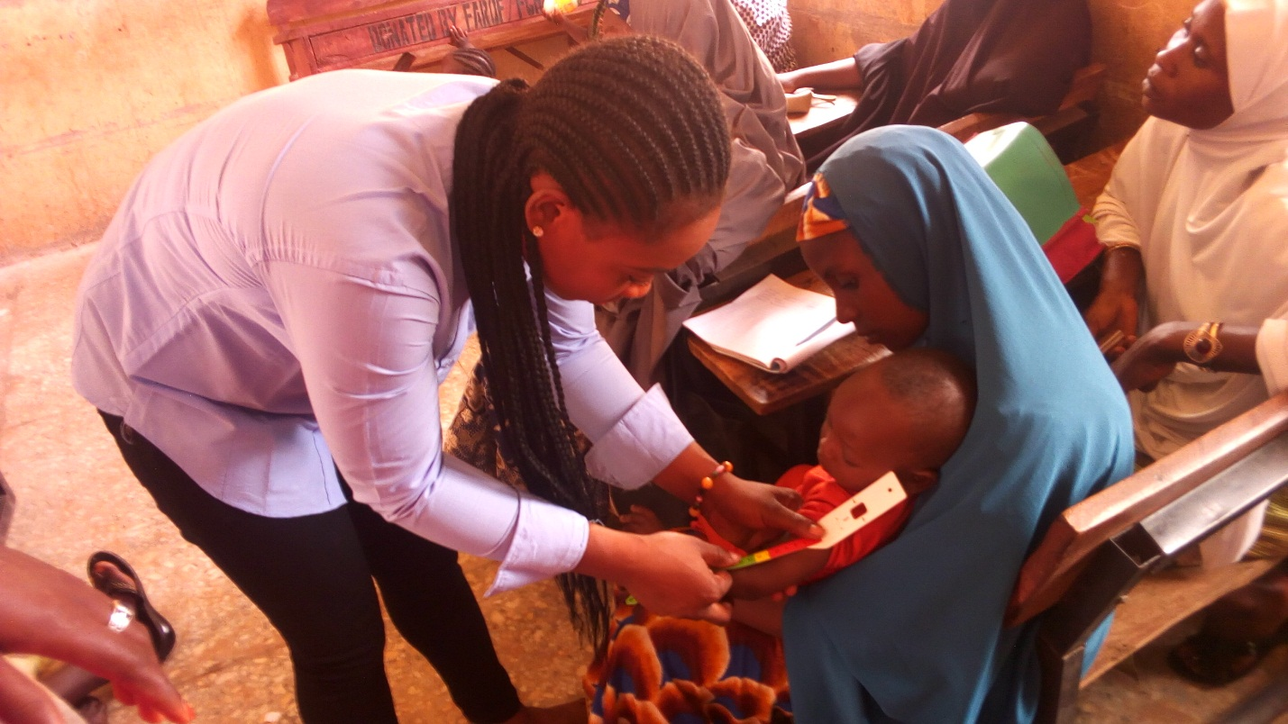
Nutritional assessment during one of the nutrition education sessions
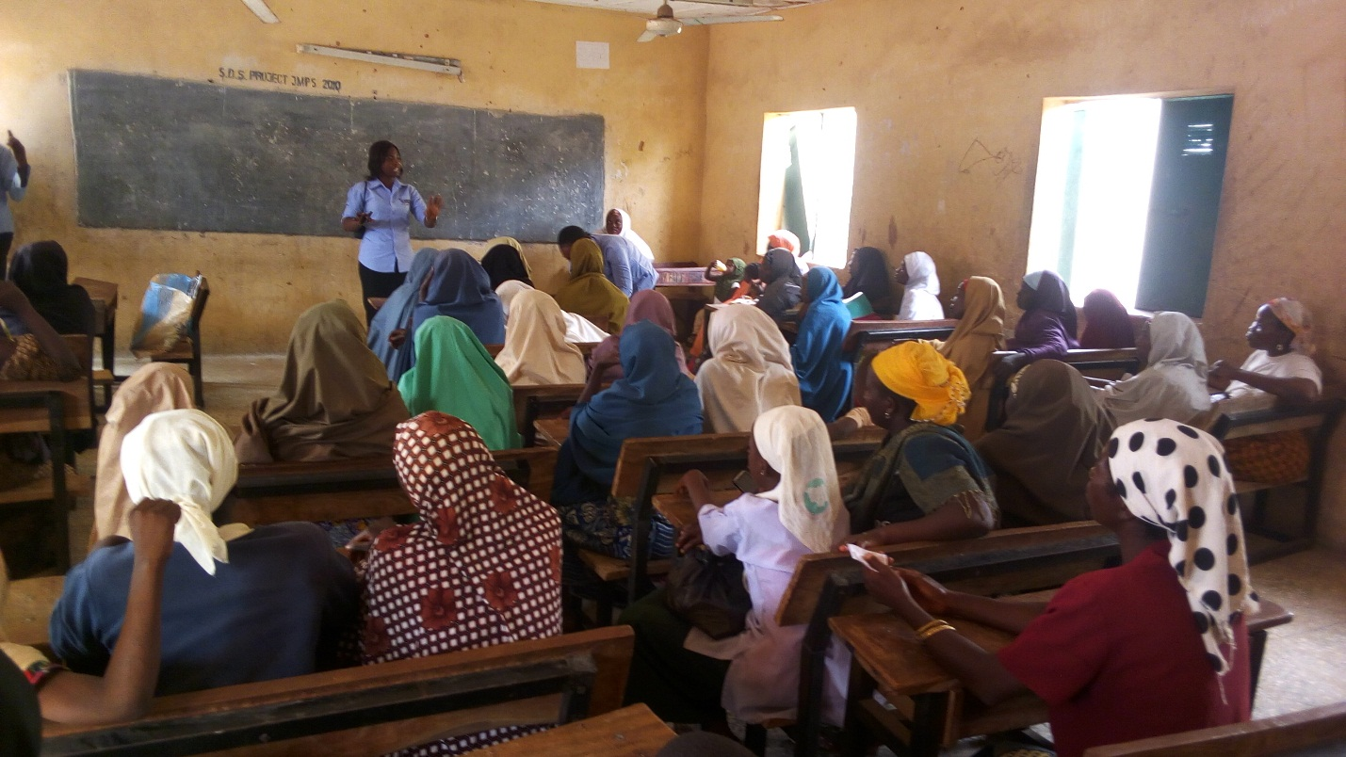

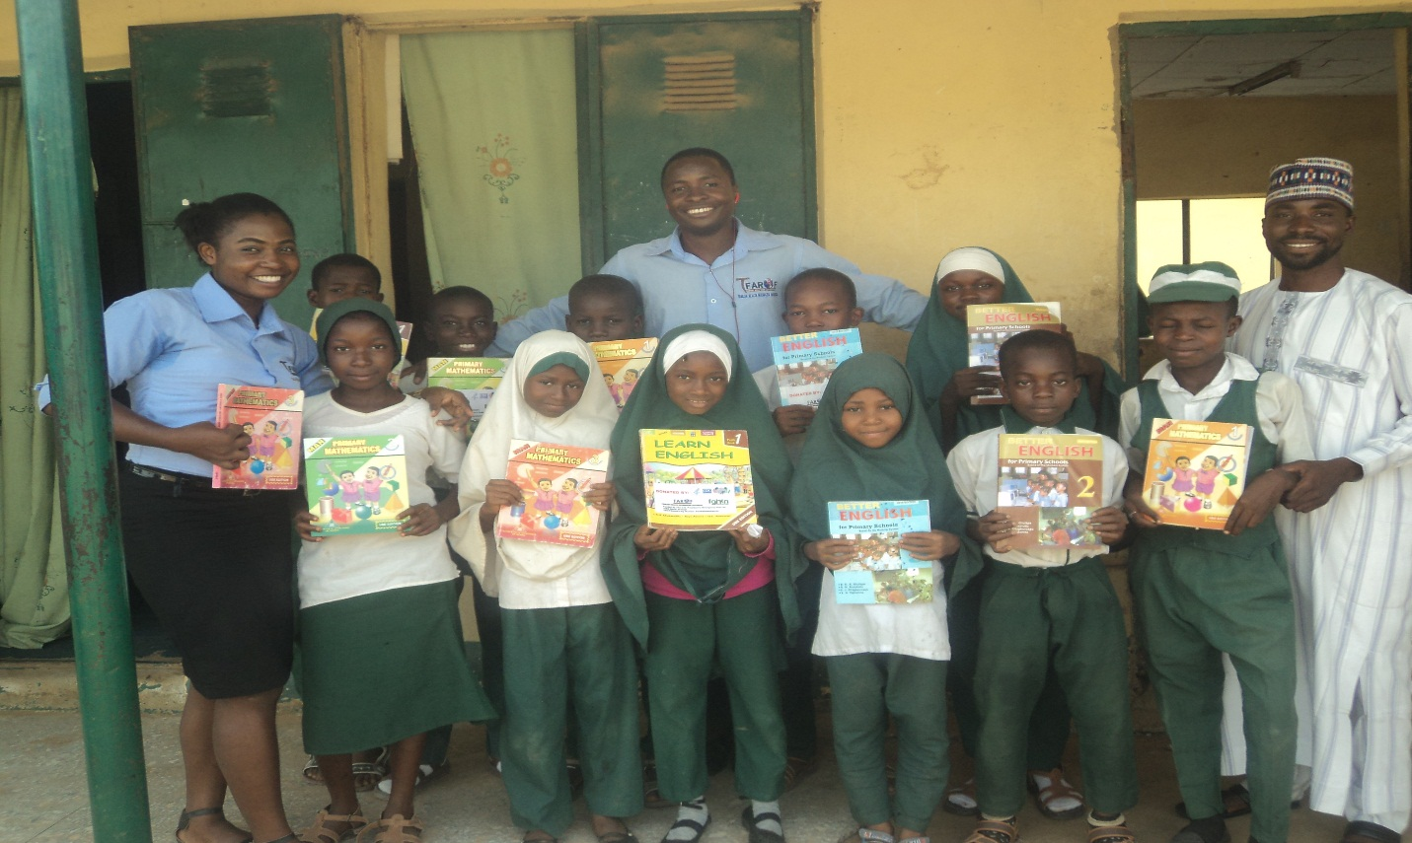
Beneficiaries provided with educational materials
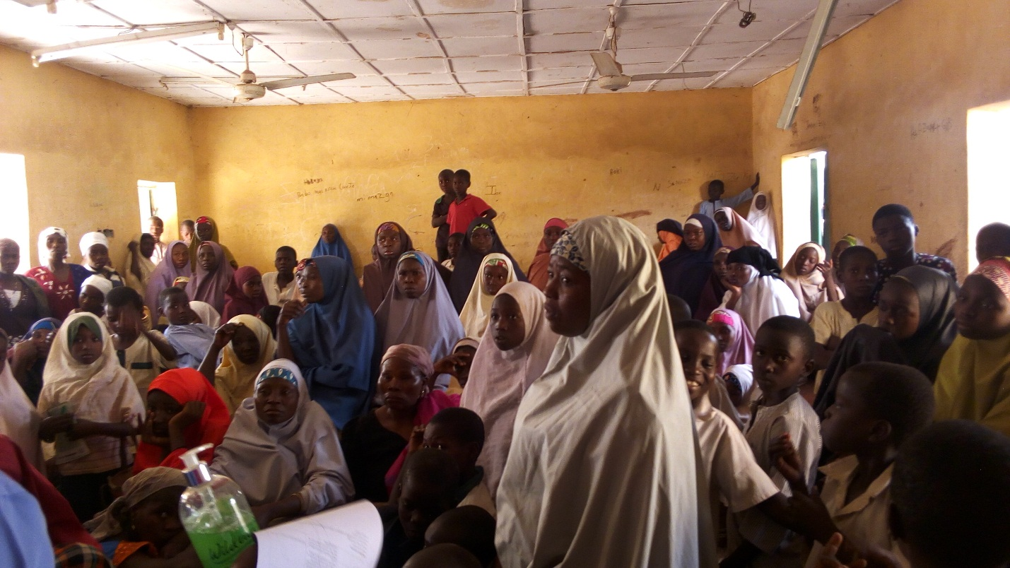
Caregivers and VCs during one of the educational session on hygiene and sanitation

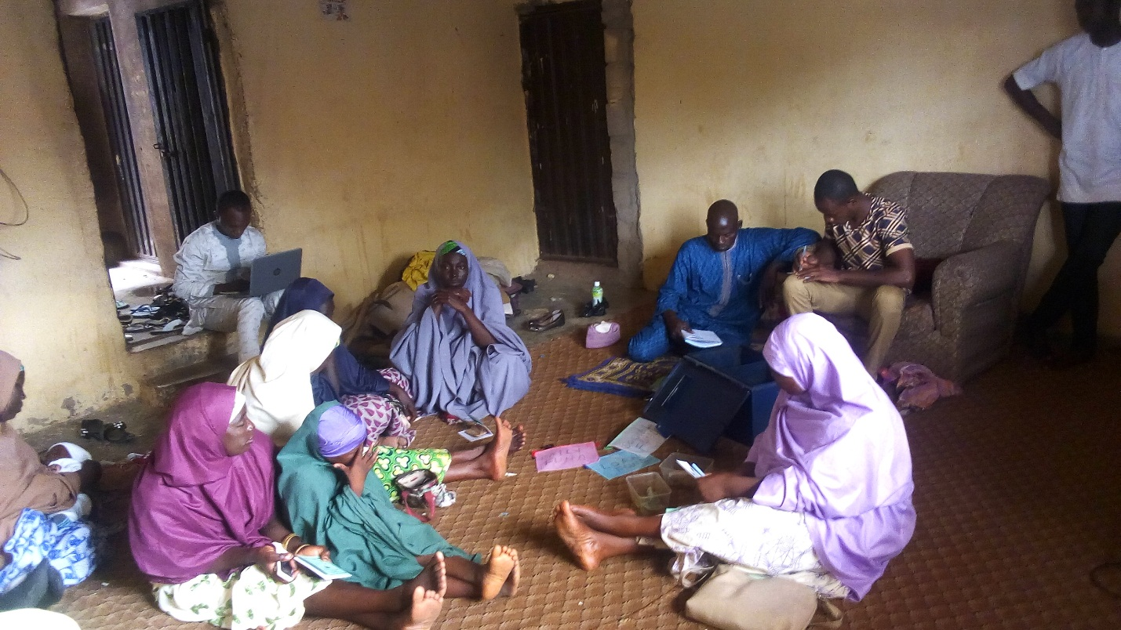
Members of the village savings and loans association
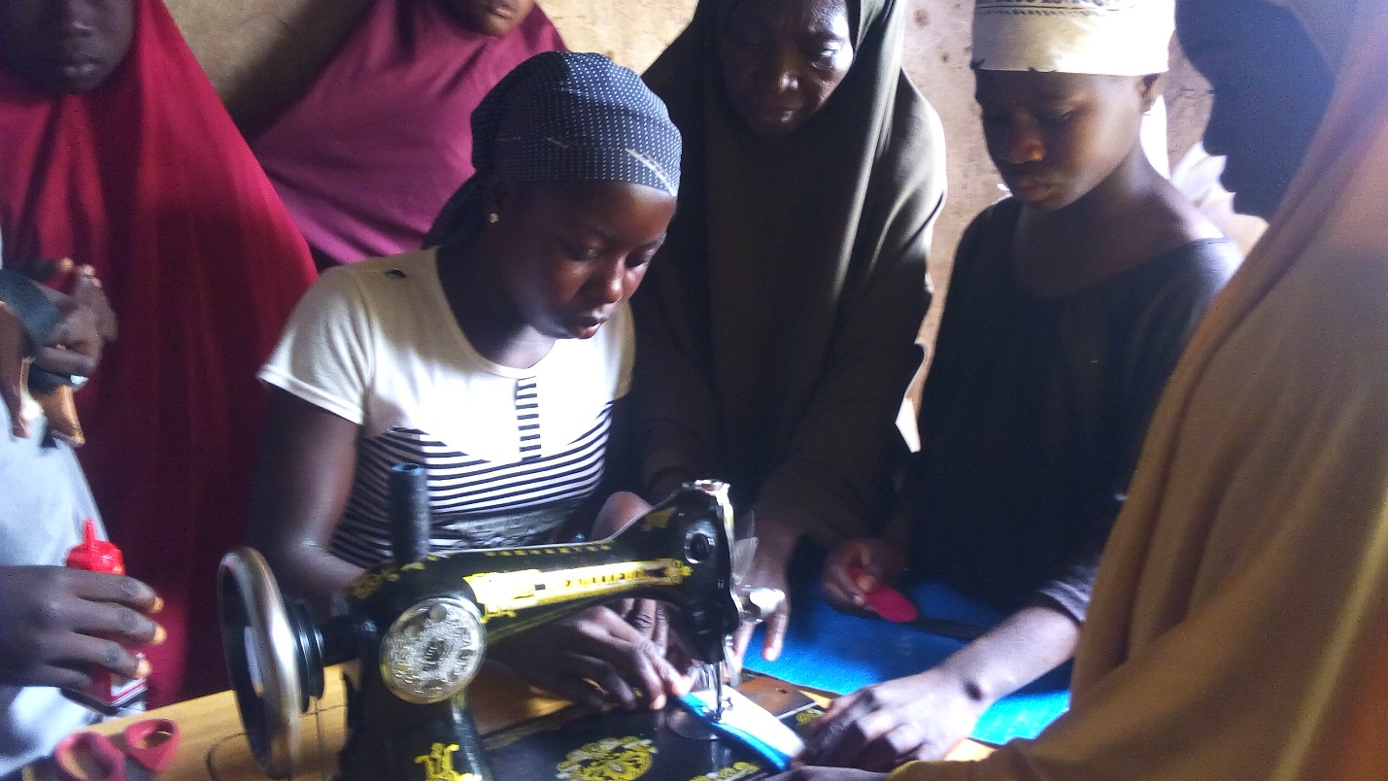
Some of the VCs at bag making center during our monitoring visit

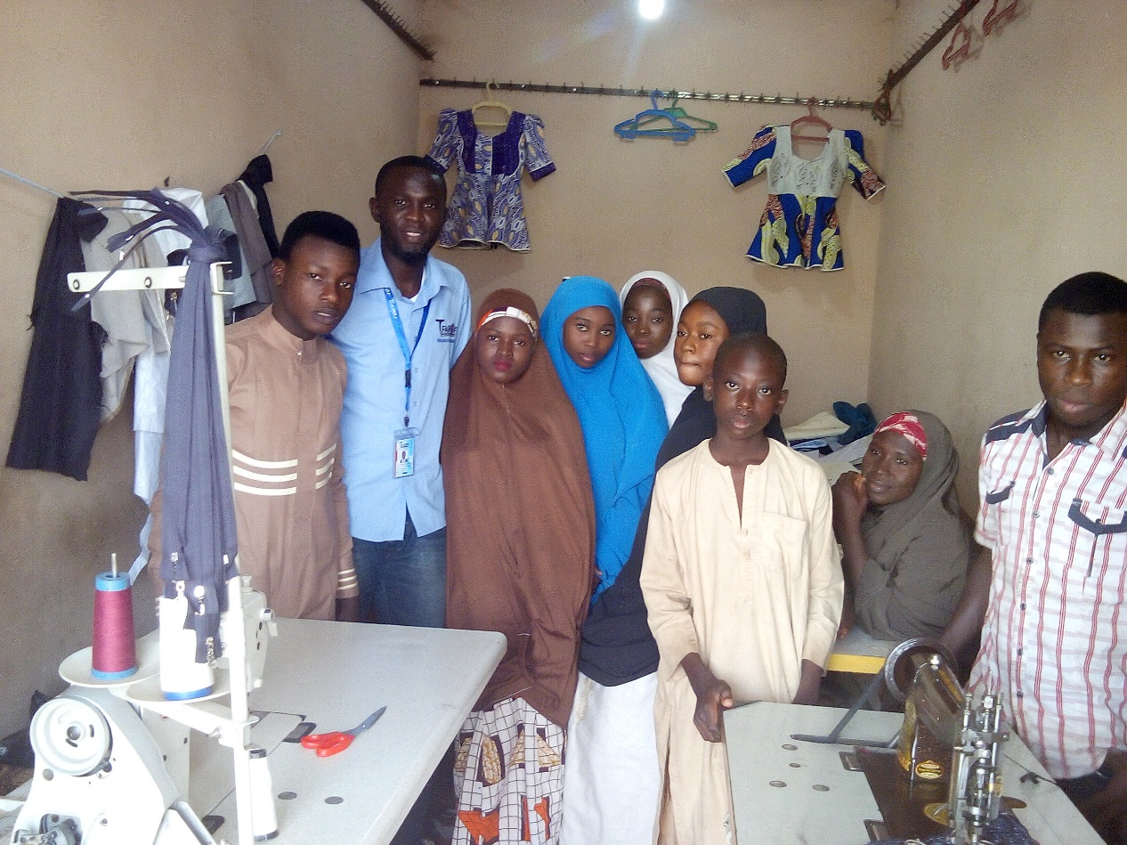
Some of the VCs at their learning center during one of our monitoring visits
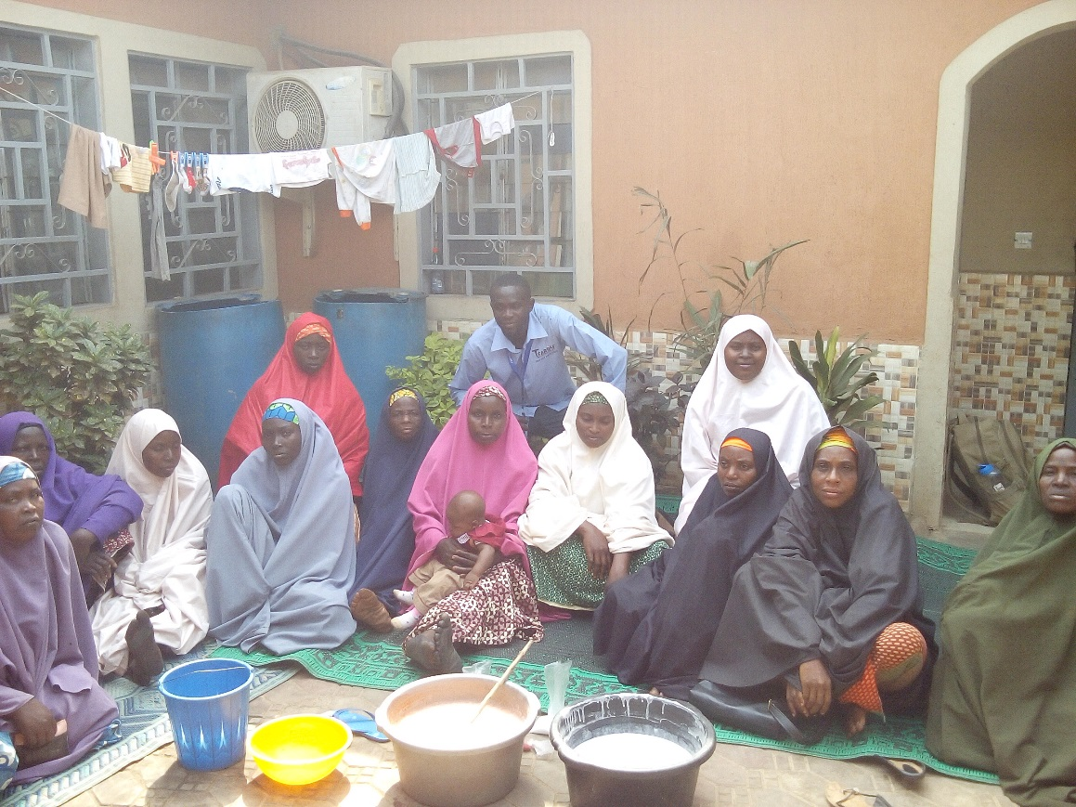
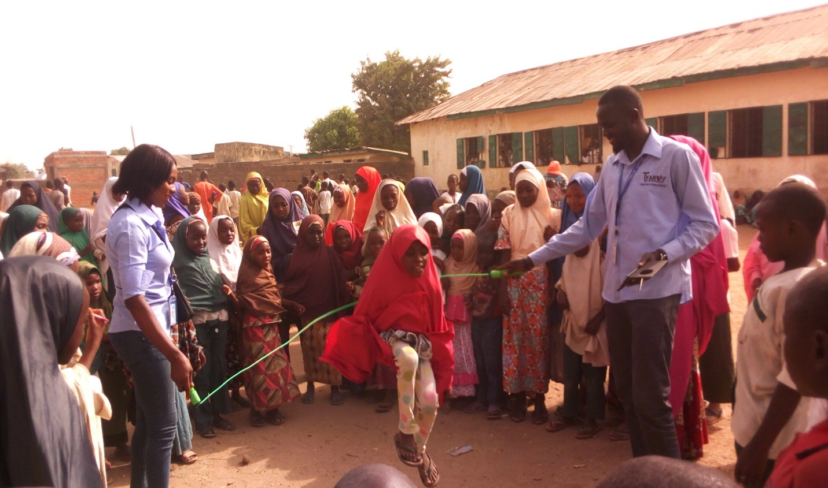
OVCs having fun during one of their kids club meetings.

