Title: | Report of HIV sensitization/menstrual hygiene program conducted for adolescents at HEKAN national youth camp
Name: | Ogundare Feyisayo
Location: | Queen Amina College, Kaduna State
Date: | 17th August, 2018

Introduction
The training on menstrual hygiene/practical on how to make reusable sanitary pad and HIV/AIDS education was conducted for adolescents during the HEKAN annual national camp program. The activity began with self-introduction of the facilitators. This activity was conducted for about 600 participants.
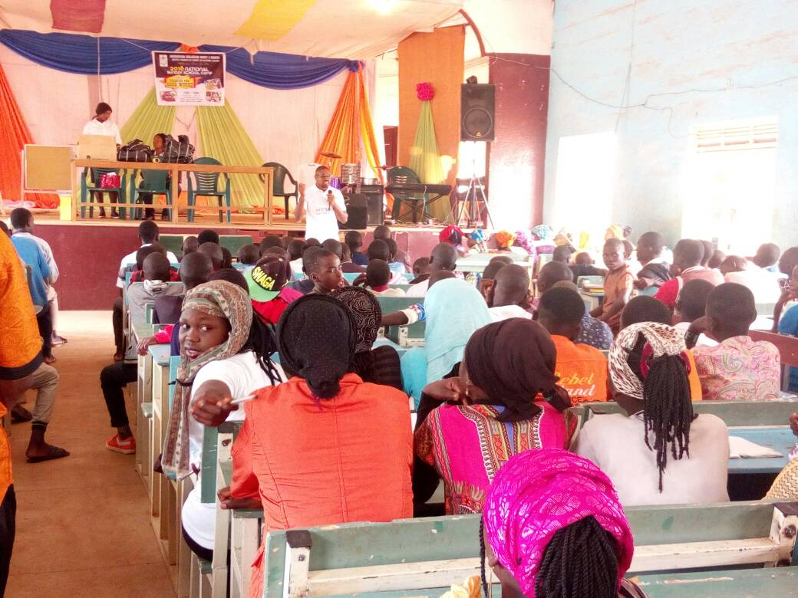
Cross section of participants

Highlights

BASIC FACTS ABOUT HIV/AIDS
- This session was handled Mr. Michael Adams. It was participatory and interactive as participants were allow to make contributions. He started by defining HIV as Human Immunodeficiency Virus, and AIDS as Acquire Immuno dificiency Syndrome. He explained further that HIV is the virus that causes AIDS and it was necessary for one to get tested so that he/she can know his status. HIV can be transmitted through Unprotected Sex with an infected person, transfusion of infected blood, sharing contaminated objects (needles, razor blades etc), Infected Mother-to-Child:
He also clarify some facts and misconception known about HIV. This includes;
- Mosquitoes can transmit HIV
- Sharing of toilets with an infected person can make one to have HIV.
- Eating food with an infected person can make one to have HIV.
At the end of the session, HIV testing and counselling was conducted for 110 persons (male-72, female-38) and their results were given to them immediately. All the persons tested were found negative.
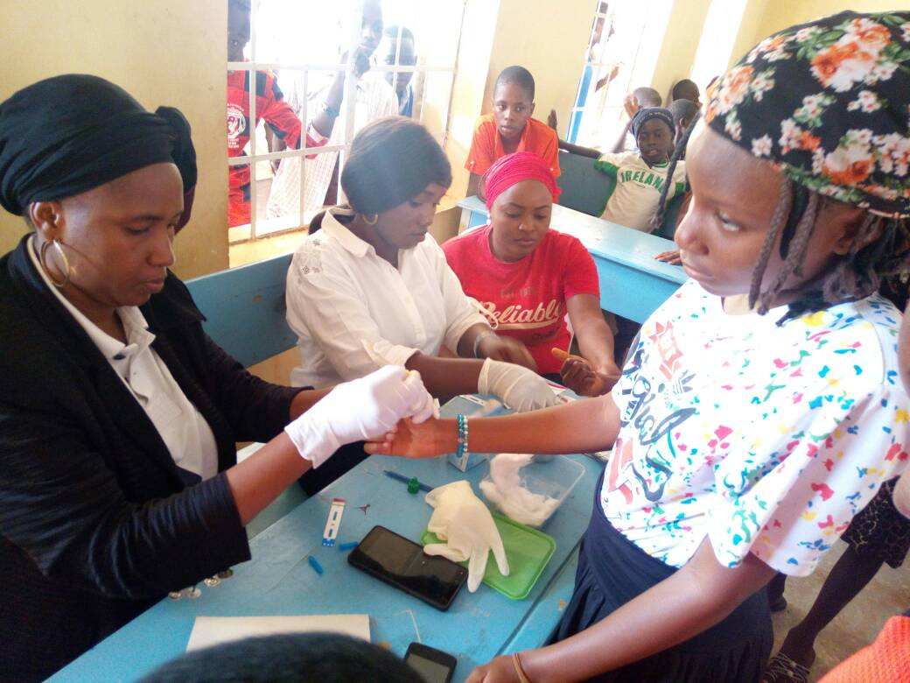
During the HIV testing exercise
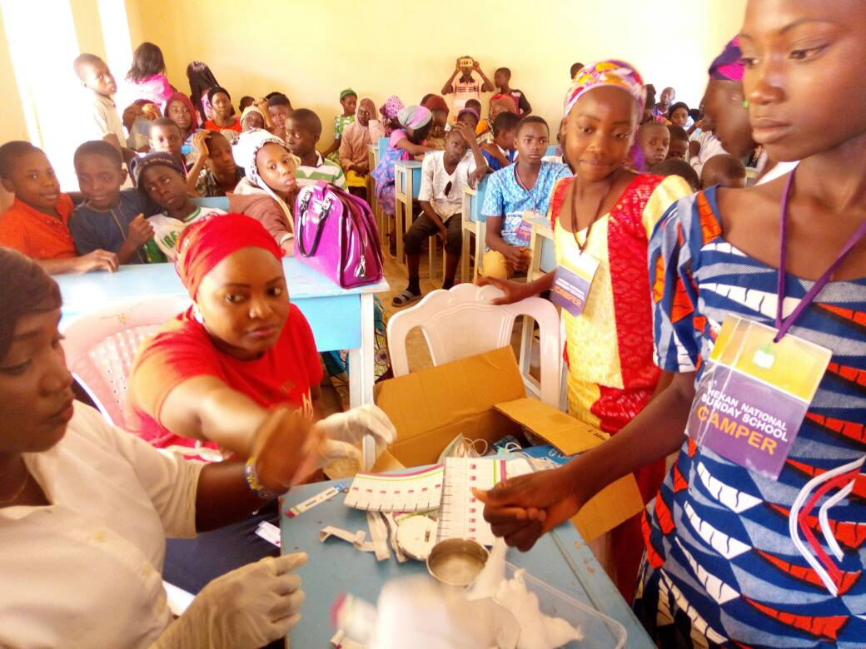
MENSTRUAL HYGIENE AND PRACTICAL ON HOW TO MAKE REUSABLE SANITARY PAD
This session was facilitated by Ogundare Feyisayo, she started by defining hygiene as the conditions and practices that help to maintain health and prevent the spread of diseases, and menstruation as the shedding of tissue and blood from the lining of the womb through a woman’s vagina. She explained further that hygiene related practices of women and adolescent girls during menstruation are of considerable importance, as it may increase vulnerability to Reproductive Tract Infections and other health risks.
Good menstrual hygiene was viewed as important because among other things it:
- Prevents infection.
- Prevents body odour.
- Enables women to remain healthy.
- Enables women to feel comfortable, confident and stay fresh all day.
- Ensures that you can continue with your daily routine such as going to school, going to work or doing household chores.
How To Make Hand Knit Reusable Sanitary Pads
The facilitator divided the participants into groups and then introduced all the materials used for making the home made sanitary pads for the training purpose and also pointed out the available options that could be gotten around them to replace the ones used for the training. The following materials were deemed appropriate:
- A premeasured cut cardboard to ease their measurement
- Pen
- Pair of scissors and tape measures or ruler
- Hand needle and threads
- Towel material
- Cotton fabric
- Leak proof
- Office pins and buttons.
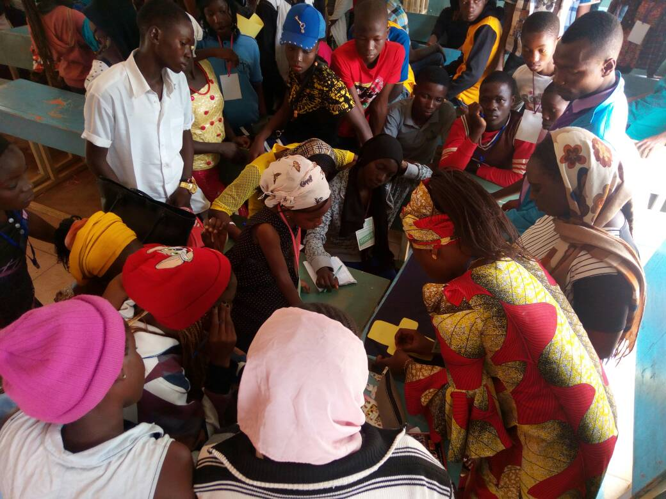
Practical session on how to make reusable sanitary pad
The facilitators then showed the participants the practical steps on how to make the reusable sanitary pad from laying out the materials, sketching the templates, cutting out the materials, and finally knitting and stitching of the pad. She also mentioned that the pad can be kept clean by washing it using disinfectants like Dettol, hypo, and dried in the sun before another use to avoid any infection.
More pictures

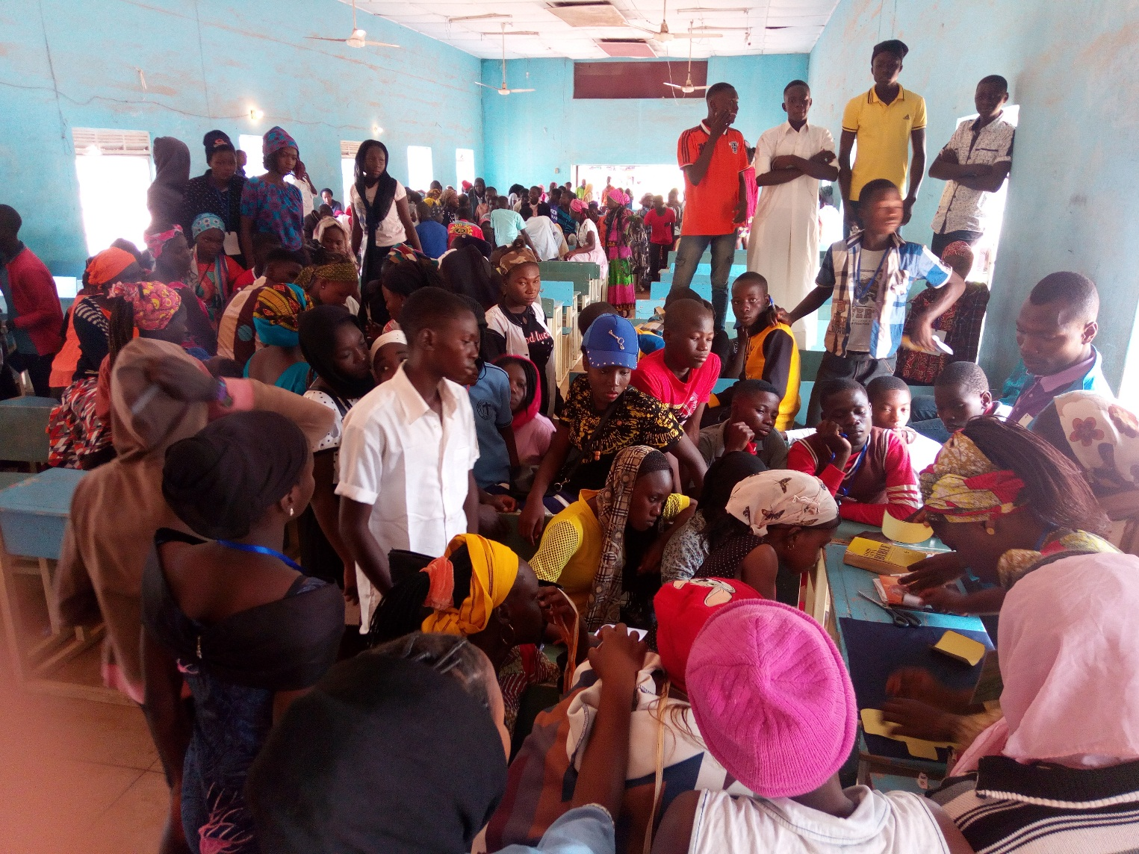Participants in groups making the reusable sanitary pads
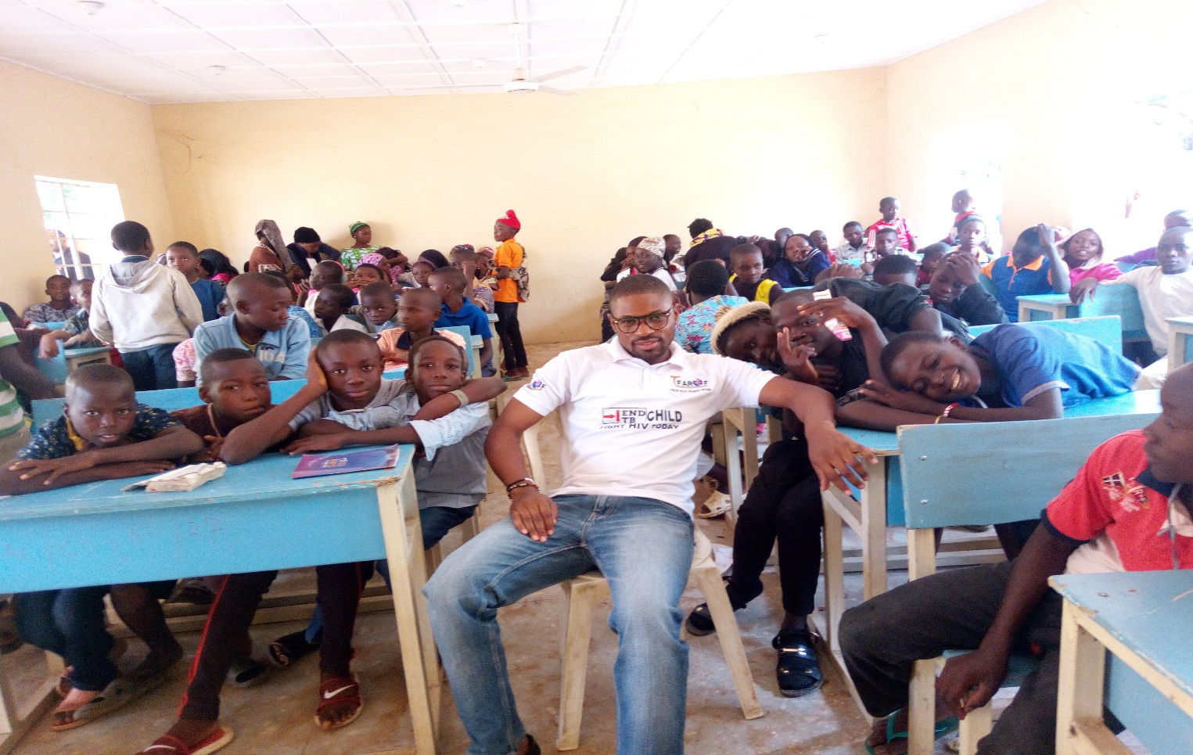
Participants waiting to be tested

